Contents
Accessing JIRA App 2
CREATE Issue: 3
JIRA Workflow: 6
Steps to Access Dashboard: 7
Steps to Access Issues Navigator: 7
Steps to View Issues Navigator: 8
Steps to make Changes in Filter: 8
Steps to Export All Issues in Excel: 9

Accessing JIRA App
1) Accessing JIRA Application. URL https://auditime.atlassian.net/login

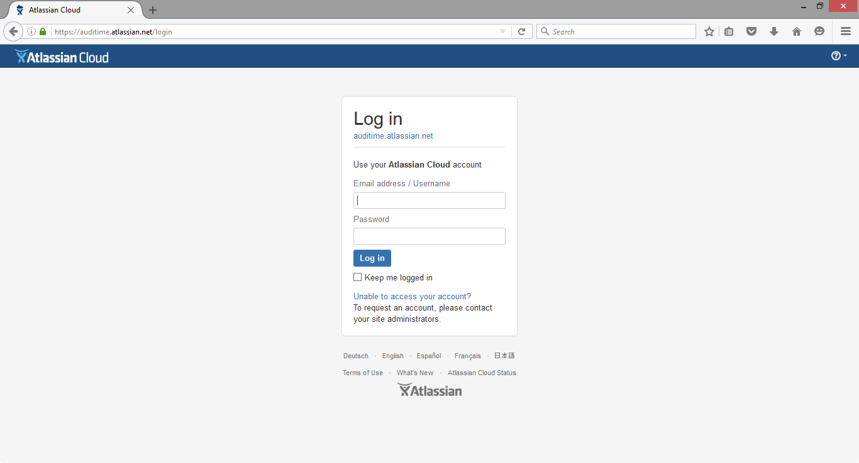

2) Login in JIRA Application with User ID as “developer5”

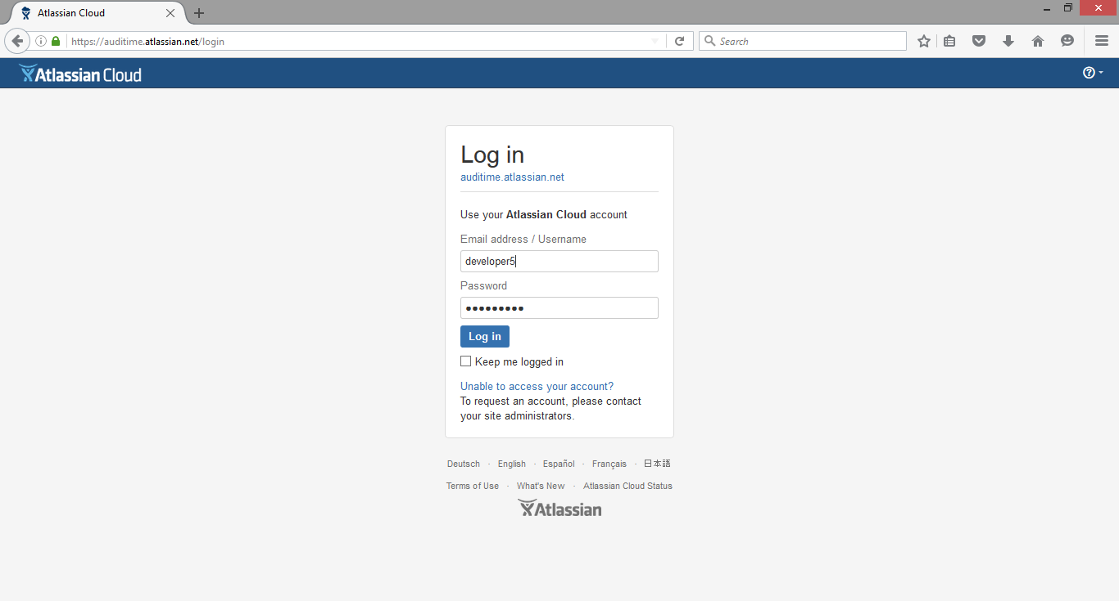

3) Selecting Specific columns for easy viewing the reported defects: Click on “Columns” and “Select” the boxes for the field to enable on the issue navigator.

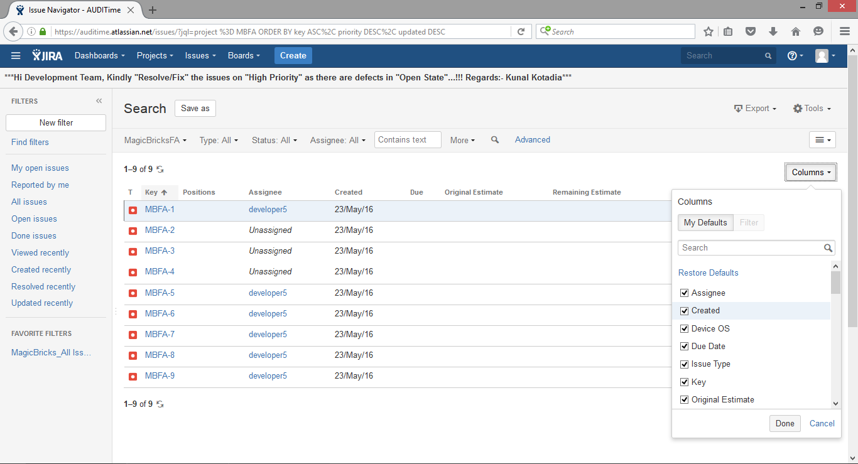

CREATE Issue:
4) Click on “Create” to log a new defect in JIRA:

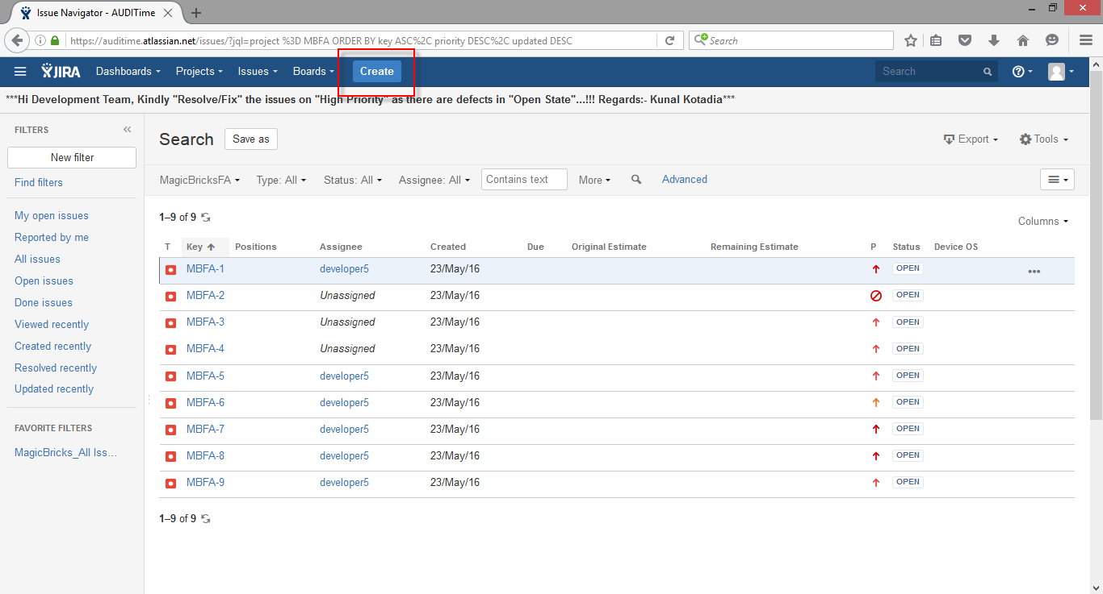

5) On Clicking “Create” Create Issue Form will get opened: (To be done by Testing Team)

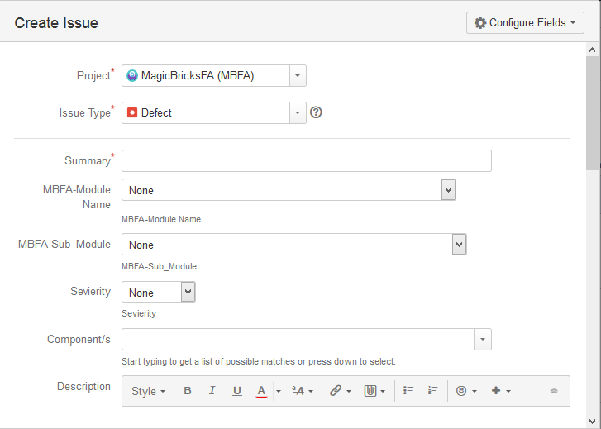

6) Select Project as “MagicBricksFA (MBFA)”
7) Select Issue Type as:
a. Defect – Recording of Bugs found during Testing
b. Enhancement – Any new changes anticipated
c. Suggestion – Any Suggestion from AQM.
8) Mention defect explanation in one liner in “Summary” field.
9) Select “MBFA-Module Name” in which defect was observed and reported.
10) Select “MBFA-Sub_Module Name” in which defect was observed and reported.
11) Select “Severity” which will represent the impact of defect reported.
12) Mentioned the detail defect explanation in “Description” field.
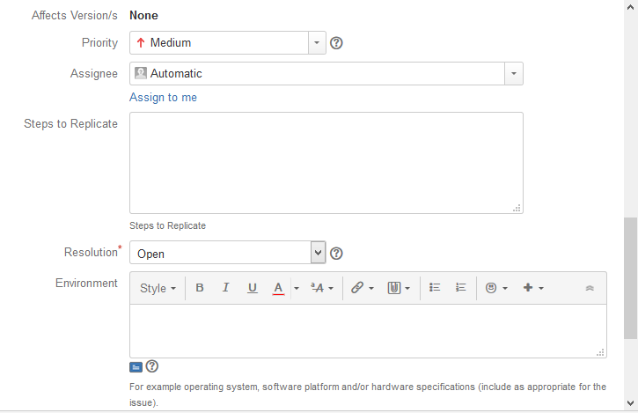

13) Select the “Affect Version/s” means the build version on which the defect was reported.
14) Select “Priority” of the defect in order to get it fixed from Development Team.
15) Mention “Steps to Replicate” for developers on the steps followed to produce the defect.
16) Select “Resolution” as “Open” by “Default” as development team will be selecting during status update for the bug status to change to “Resolve” state.
17) Mention the “Environment” on which the defect as found. Eg. “Internet Explorer 10”
18) Mention the “Test Case ID” if the defect is reported on execution of test cases. Comma Separated in case of multiple.

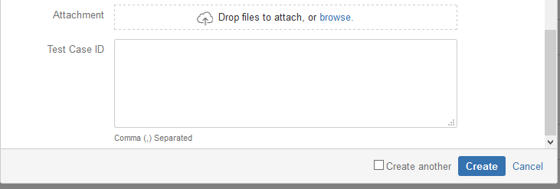

19) Click on “Create” button if the above mention details are correct and wants to create a Defect ID in JIRA.
20) JIRA ID will be created once the “Create” button is clicked.

JIRA Workflow:
1. Developer needs to “Start Progress” on the raised issue and needs to assigned himself
2. Developer can “Resolve Issue” or “Hold” issue with appropriate “Resolution”
3. Once the Status of the Defect is in “Resolved” State than Testing will be carried out to verify whether the defect is fixed properly with Impact analysis.
4. Testing team will click on “Closed” if the resolved defect is working fine and is not replicated again.
5. Testing team will click on “Reopened” if the resolved defect is not functioning as per the requirement and is getting replicated again.
6. After the defect is “Closed” testing team can “Reopened” the defect is replicating again after the releases from development team.
7. All the issues which are in “Reopen”, “Open”, “Hold”, “In Progress”, “Assigned” State needs to be “Resolved” by Development team. However development team will not have rights to “Closed” any defects.

Following will be the combination of “Status” and “Resolution” as a part of JIRA WorkFlow:
Status | Resolution | Remarks
Open | Unresolved | Indicates that issue is still not fixed but assigned
Open | Open | Indicates that issue is still not fixed and not assigned
Resolved | Fixed | Indicates that issue is fixed and given for retesting which will be closed or reopen by testing team
Resolved | Won't Fix | Indicates that issue is dropped and not going to be fixed so decision to be taken by MagicBricks Team with proper comments
Resolved | Duplicate | Indicates that same issue is logged twice hence to be closed by Testing Team
Resolved | Cannot Reproduce | Indicates that the Steps mentioned in issue is not sufficient to reproduce. Testing team will close or reopen if replicated again
Resolved | Discussed & Closed | Indicates that raised defects can be closed after discussion hence testing team will close or reopen as per requirement
Hold | Deferred | Indicates that defect will be fixed on later stage. Hence it needs to be kept on hold from development end
Resolved | Not A Defect | Indicates that the mentioned in issue is not a defect as per requirement. Testing team will close or reopen if replicated again
Hold | To Be Discussed | Indicates that defect will be fixed on later stage as it is under clarification. Hence it needs to be kept on hold from development end
Resolved | Out of Scope | Indicates that these are suggestions provided by Auditime Team and further action will be taken by testing team for Close/Reopen
Hold | Requirement Change | Indicates that there are changes in requirement and to be kept on hold untill decision is not clear from MagicBricks Team with proper comments

Steps to Access Dashboard:
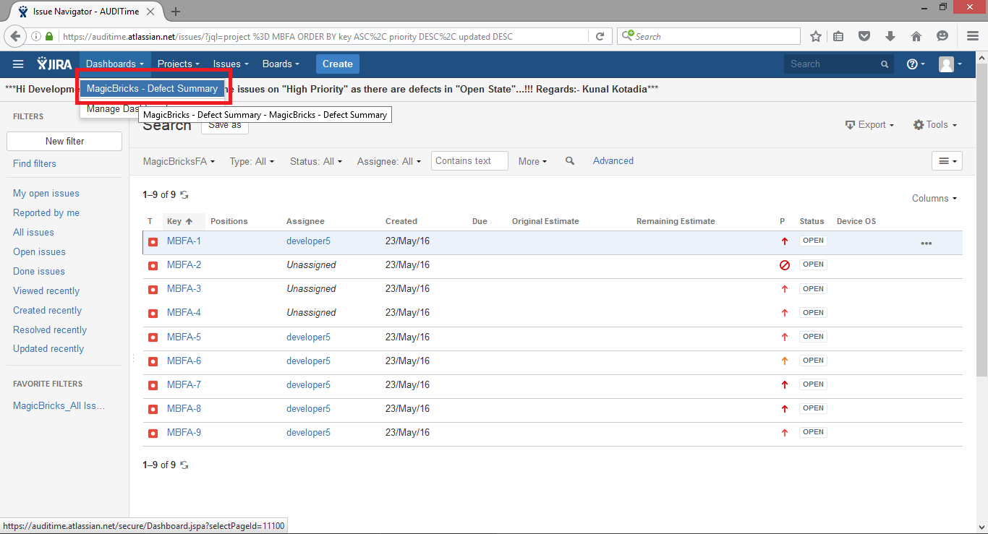

Steps to Access Issues Navigator:
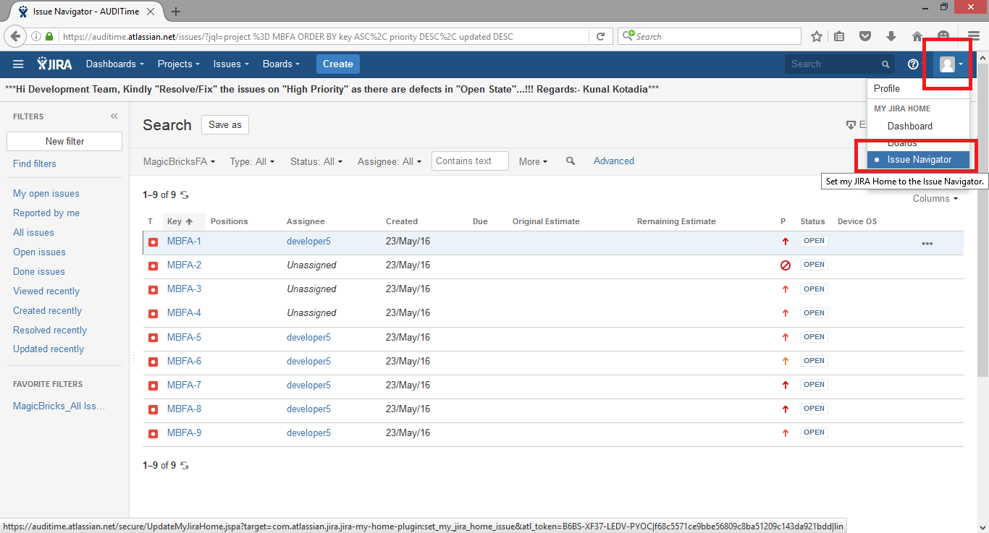

Steps to View Issues Navigator:
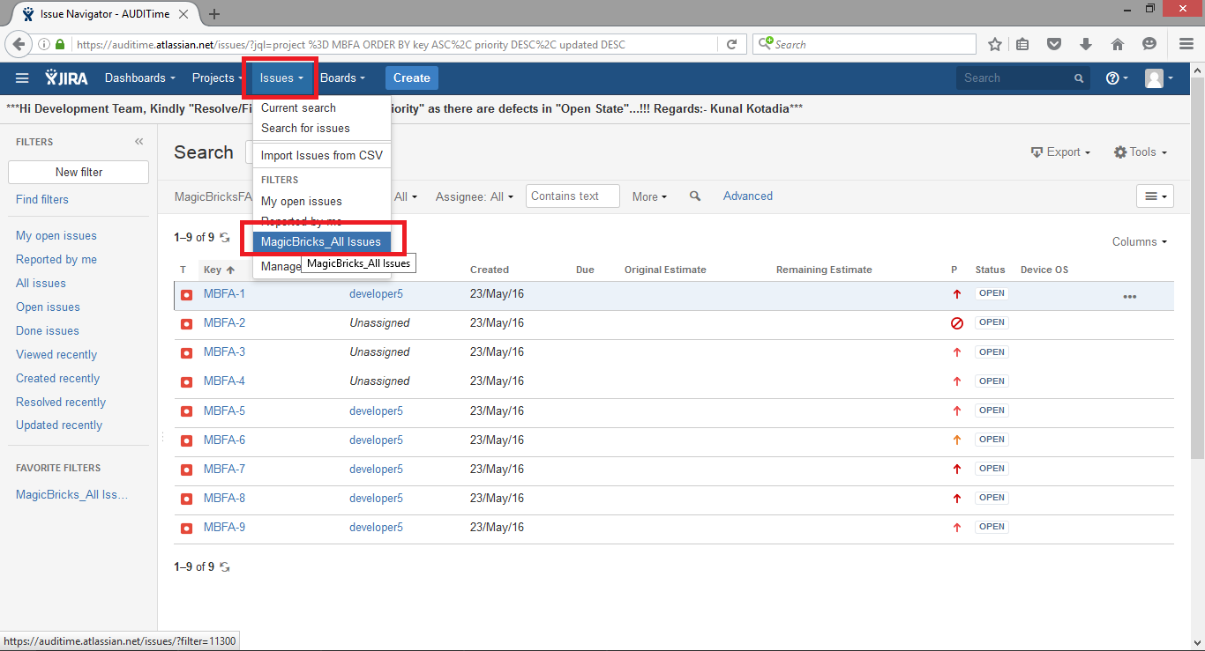

Steps to make Changes in Filter:
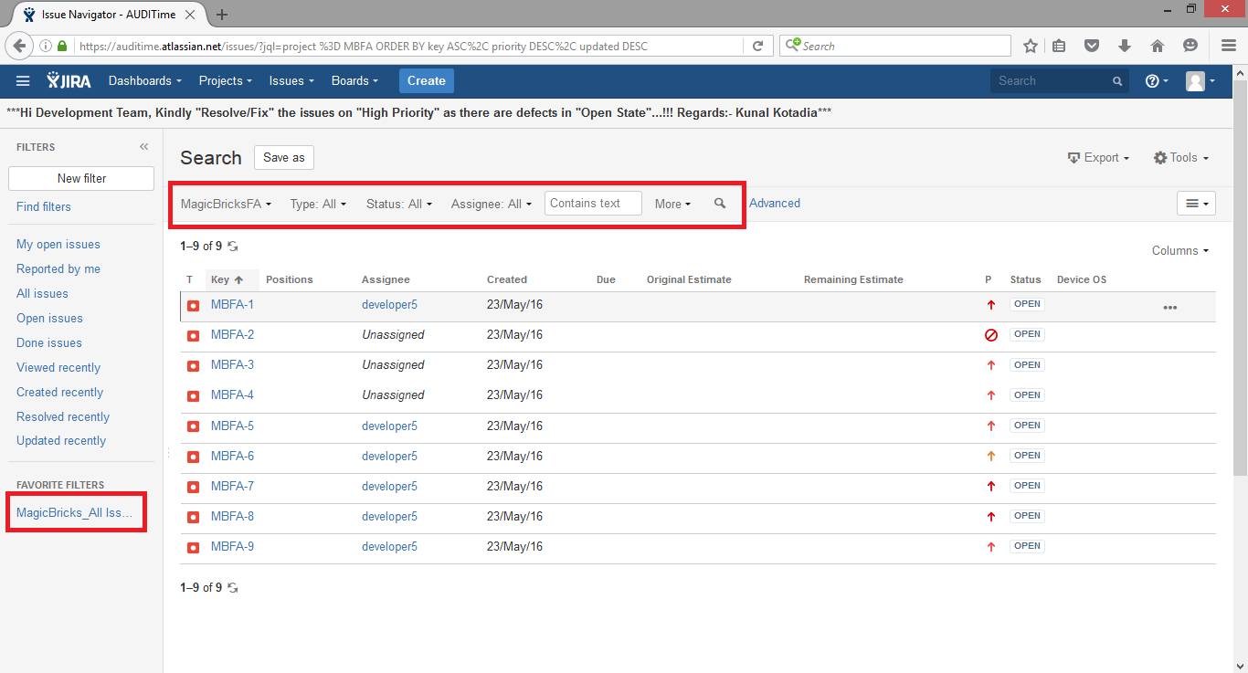

Steps to Export All Issues in Excel:
